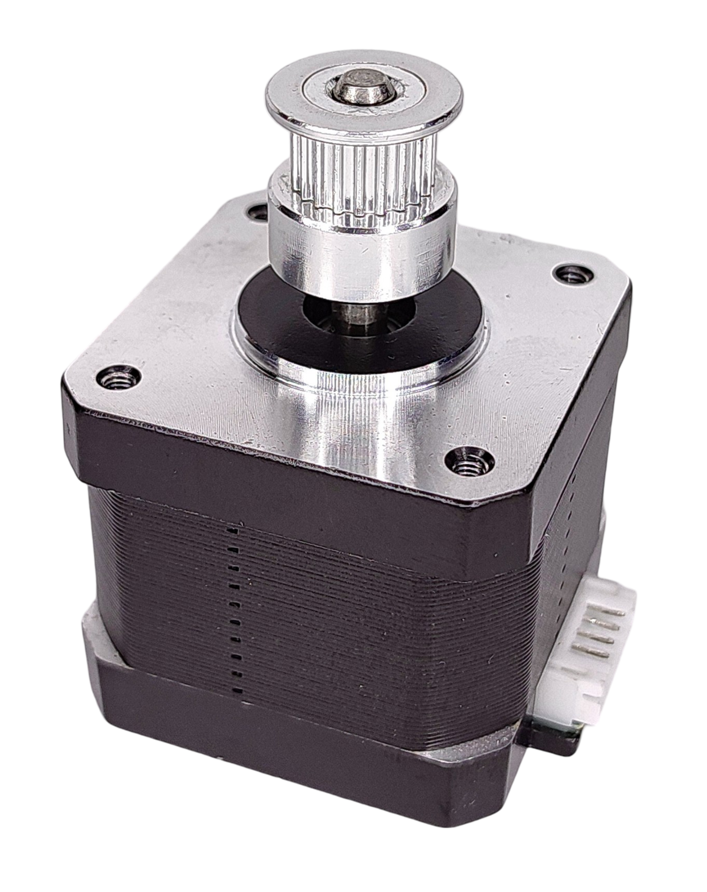
Microstepping Chart

Frame Size: NEMA 17
Rated Current: DC 1.5A/Phase
Holding Torque: 0.42N·m
Step Angle (degrees): 1.8°
Phase Resistance: ~2.4Ω/Phase

Test Conditions:
◾ A4988 driver used for all tests
◾ Tested at 25%, 50%, 75%, and 100% of the rated current
◾ Tested with a driver supply voltage of 12V and 24V
*(some of the higher-voltage, higher-current data points were corrupted due to driver overload)

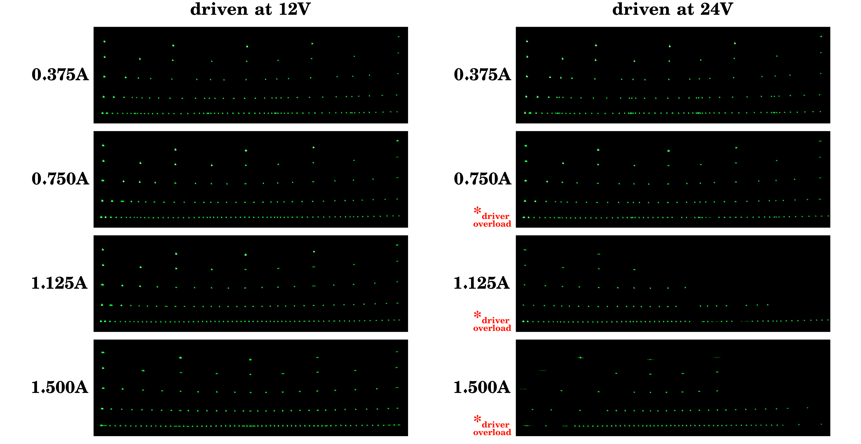

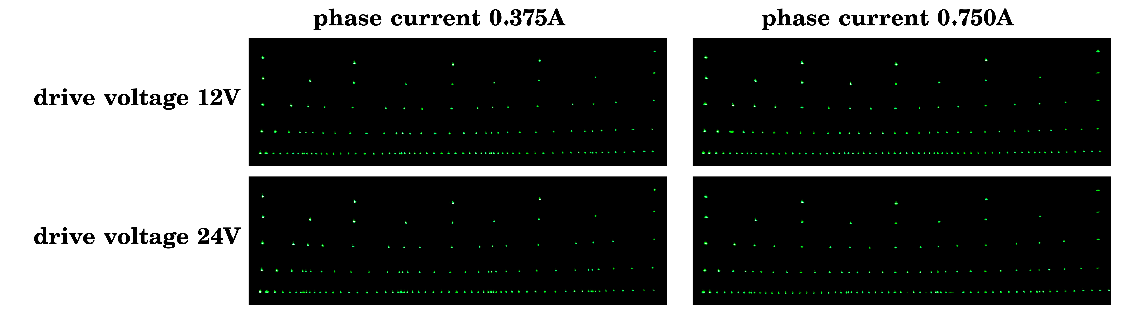
Notes:
◾ Every pattern was created at the indicated voltage and current levels by a laser galvo projector with the X-mirror actuated by the test subject. In automated fashion, a line of dots was drawn with the driver set to full steps, then the same row in half steps lined up underneath, then quarter steps, etc., all the way down to sixteenth steps.
◾ Due to the limited exposure duration of my camera, some combinations of drive current and voltage resulted in motion blur from the mirror ‘bouncing’ more than usual before settling at its intended target position. Other than in extreme cases, this should not significantly impact data accuracy.
◾ At ‘high’ voltages and currents of 24 volts and more than 1 ampere, the A4988 driver quickly overheats, which seems to make it extremely susceptible to electrical noise and glitching and unfortunately resulted in erratic behavior like lost steps, making execution of a complete test pattern impossible. Step detent points should still be valid wherever they visually appear in the correct location though.

